Establishing the First Earthen Analog of Martian Concentric Crater Fills: Characterization of the Debris Apron of Crater Glacier

Martian debris-covered ice deposits are found across the mid-latitudes in various landforms including concentric crater fills (CCFs). (Fact) These ice deposits are mostly frozen water with very few inclusions of other materials, making them crucial testbeds for the effects of moving ice on the Martian landscape and potential life on the surface. (Importance of Fact) However, CCFs do not currently have a known analog site on Earth, which is necessary to translate our Earthen understanding of microbial life to Mars. (Problem) We propose a field expedition to identify and characterize the contents and layering of the debris covering Crater Glacier, a debris covered glacier within the explosion crater of Mount Saint Helens that has extremely similar flow patterns to CCFs. (Goal) Using radar data from the field mission, and X-ray fluorescence from the resulting samples, we will clarify the contents of the debris. (Solution) This program will establish the benchmark for future studies of viscous flows in Martian craters, as a basaltic covering within a crater is the closest analog on Earth to the composition of Mars. (Importance) In the age of sample return and possible human exploration on Mars, a complete conceptualization of solid water ice flows on Mars enabled by direct Earthen analogs is imperative to identify potential life on Mars. (Broader Impacts)

Section 1:
- The Need for a CCF Martian Analog
  - Fact Paragraph:
    - We are in the era of sample return and human exploration of Mars, which water heavily impacts.
    - Martian debris-covered ice deposits are found across the midlatitudes and have some concentration of pure water ice, including concentric crater fills (CCFs). (Holt et. al, 2008), (Berman et. al, 2021) Many methods have been proposed to extract water from these glaciers for human missions, but more characterization is required for use. (Morgan et al, 2021) In addition, glaciers are a known habitat for microbial life. (Skidmore et al, 2000)
    - These ice deposits are mostly frozen water with very few inclusions of other materials, making them crucial testbeds for the effects of moving ice on the Martian landscape and potential life on the surface.
  - Problem Paragraph:
    - However, CCFs do not currently have a known analog site on Earth with an active glacier within a crater, which is necessary to translate our Earthen understanding of microbial life to Mars.
    - Galfore et al, 2021
    - This more direct analog is necessary to translate our Earthen understanding of microbial life to Mars, as the Perseverance mission searches for evidence of past life on the surface.
  - Synopsis Paragraph
    - We propose a field expedition to identify and characterize the contents and layering of the debris covering Crater Glacier, a debris covered glacier within the explosion crater of Mount Saint Helens that has extremely similar flow patterns to CCFs.
    - This study will be the first study of its kind regarding analogs to an active CCF on Earth, which fulfills the Solar System Science program’s goal of “supporting the most meritorious research [and] data analysis…and encourages efforts that involve…[convergent] research”, in addition to serving the Decadal Scale question of “Where and How Have Glacial Processes Sculpted Landscapes?”.
    - This program will allow for future studies of viscous flows in Martian craters, as a basaltic covering within a crater is the closest analog on Earth to the composition of Mars. This analog is crucial in the age of sample return and possible human exploration on Mars. A complete conceptualization of solid water ice flows on Mars enabled by direct Earthen analogs, which this program will allow for community access to, is imperative to identify potential life on Mars.

Section 2:
- CCFs’ Lack of Known Analog Site Impedes Understanding of Mars
  - Field expeditions have been taken to analogs of other viscous flow types. These have helped to isolate the depth of the debris cover, the glacier’s movement over time, and identified high resolution radar as a possible tool for investigation on Mars. However, this research has not been done for CCFs.
  - Petersen et al, (2020)
  - Understanding the composition and movement of CCFs allows us to piece together currently unknown geomorphologic processes in glacier fields on Mars, which would affect the possible presence of life.
  - Crater Glacier’s cover composition is currently unknown; if it is basalt, it would be a much closer analog to any viscous flow analog being studied.
  - Using radar data from the field mission, and X-ray fluorescence from the resulting samples, we will clarify the contents of the debris.

Section 3:
- This Proposal: Characterize the Covering and Possible Habitat of CCFs via Crater Glacier
  - Our ultimate goal is to identify the contents of the covering, and the viability of CCFs as a habitat for microbial life.
  - This study will be the first study of its kind regarding analogs to an active CCF on Earth, which fulfills the Solar System Science program’s goal of “supporting the most meritorious research [and] data analysis…and encourages efforts that involve…[convergent] research”, in addition to serving the Decadal Scale question of “Where and How Have Glacial Processes Sculpted Landscapes?”.
  - We will use multiple strategies to understand CCFs:
    - Using radar, we will map the glacier interior to a [x] scale to understand the depth of the covering.
    - We will take samples of the covering to verify its composition with XRD.
    - In addition, we will take biological samples to understand if any life is living in the crater.
  - This will result in:
    - A full map of the depth of a covering of a glacier within a crater, including variations in depth from the walls to the center.
    - Complete spectra of glacier covering.
    - List of any and all microbes living under or near the glacier.
    - This will be compounded with current maps of Crater Glacier’s movement from it’s formation in 1999 to now.
  - Our products will tell us how similar Crater Glacier is Mars CCFs, including it’s velocity, area, and composition of the covering, how thick we can expect the covering to be, and what life would look like if it was Earthen and existed near the glacier, filling the knowledge gap that currently exists around CCFs.

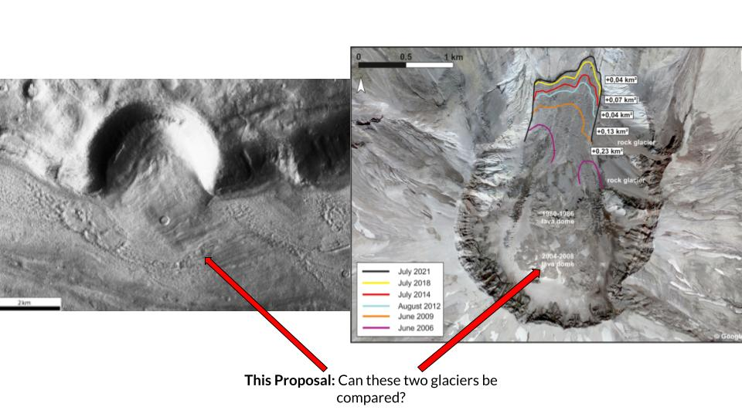
Figure 1: Clarifying the ability to use Crater Glacier (right) as an analog for Mars CCFs (left) will allow for further research into viscous flows on Mars and widen the opportunity for more discoveries in space travel and astrobiology. The left image shows a Mars CCF with the fill spilling out of the edge of the crater, similar to Crater Glacier on the right. In addition to some CCFs having the same shape as Crater Glacier, they also share the presence of a rubble layer, and presence in a crater. Currently, CCFs do not have a known analog site on Earth, which is necessary to translate our Earthen understanding of microbial life to Mars.We propose to use radar and biological sampling to demonstrate Crater Glacier’s analog potential and possible astrobiological implications for Mars.

Section 4:
- Broader Impacts in the Context of the Decadal Survey: Identifying Glaciers on Mars as a Habitat for Life
  - This study will allow for the analysis of Crater Glacier as an analog for CCFs on Mars in 3 phases: 1) The taking of Radar data for mapping and depth assessments; 2) Identification of the debris cover; and 3) Identification of any biological life around the glacier. This moves forward our understanding of Crater Glacier itself, as well as CCFs, water ice, and the astrobiological potential of glaciers on Mars.
  - This is critical in the sample return and human exploration age of Mars and will fulfill the Solar System Science program’s goal of “supporting the most meritorious research [and] data analysis…and encourages efforts that involve…[convergent] research”, in addition to serving the Decadal Scale question of “Where and How Have Glacial Processes Sculpted Landscapes?”.
  - Study of Crater Glacier will allow for further research into viscous flows on Mars and widen the opportunity for more discoveries in space travel and astrobiology in the future.

Sources:

Radar Sounding Evidence for Buried Glaciers in the Southern Mid-Latitudes of Mars

Ice-rich landforms of the southern mid-latitudes of Mars: A case study in Nereidum Montes

Availability of subsurface water-ice resources in the northern mid-latitudes of Mars | Nature Astronomy

Microbial Life beneath a High Arctic Glacier | Applied and Environmental Microbiology

A Comparative View of Glacial and Periglacial Landforms on Earth and Mars

Surface roughness prevents radar penetration of some Martian debris-covered glaciers

